KCGRC Annual Awards and Trophy Guidelines
(revised December 31, 2024)

Members are encouraged to apply for these annual awards and trophies. The following are the KCGRC Trophy Guidelines, which were voted into effect at the regular May 1990 meeting and amended by the Trophy Committee and Board in 1993, 1996, 2001, 2008, 2020, and again in 2024. The Challenge period starts January 1st and ends December 31^{st.} The deadline for turning in trophy applications is the first week of February following the end of the challenge period unless otherwise stated by the Trophy Chairman.

1. MEMBER: Only titles and wins earned while the owner of the dog is a member in good standing and having been a member for at least 1/2 of the trophy year shall be recognized.

2. ACTIVITY REQUIREMENT: For dogs to be eligible to receive ALL AWARDS AND TROPHIES, separate from competitive trophies, the owner(s) must be an ACTIVE member of KCGRC. Active member is defined as volunteering at 2 KCGRC events, presiding as a Board member/officer or as a Chair of a committee each year. Serving on committees, working at Dog Show Specialties, WC/WCX tests, TD/TDX Tests, Agility/Obedience/Rally Trials, or other club functions will be considered as fulfillment of requirement. (Special circumstances may be considered by the trophy committee and KCGRC Board if advised in writing when submitting for award.) This shall be strictly enforced.

3. RETURN REQUIREMENT: All competitive trophies must be kept in good condition by the recipient and returned to Regal Awards & Advertising, 6370 College Blvd., Overland Park, KS 66211 by the last week of January or first week of February for cleaning and engraving. If a member is planning to move out of the area, the trophy is to be returned prior to departure. Damage, other than normal wear and tear, are the recipients’ responsibility.

4. Retirement of the competitive trophies shall be agreed upon at the time of sponsorship and/or when all space for engraving is filled.

5. All wins and titles must be verifiable either by AKC report results, Golden Retriever News, or copy of Title Certificate.

- All new trophies and guidelines must be approved by the trophy committee and KCGRC Board.

- Those goldens co-owned on AKC Registration with a person who is not a member of KCGRC must predominantly reside with the KCGRC member and/or be 50% or greater financially supported for food, vet and competition expenses by the member, to be eligible for KCGRC COMPETITIVE trophies. (Special circumstances may be individually taken to the trophy committee and KCGRC Board.)

- Awards, wins, titles, etc. will only be recognized when properly submitted to the trophy chairperson by the specified date. Any new titles sanctioned within the challenge year will be recognized in that trophy year.

- KCGRC plaques will be awarded to members’ Golden Retriever dogs that have attained their first titles from the American, Canadian, United Kennel Clubs, GRCA and other organizations. Trophy Bars will be provided and awarded to members’ Golden Retriever dogs’ that have attained additional titles from the accreditation clubs AKC and GRCA. Those Goldens that earned titles through all other organizations may request, provide Title Certificate and pay for bars when completing trophy forms.

10. Members’ dogs who achieve titles that are NOT GOLDEN RETRIEVERS will be awarded a certificate of merit for titles earned.

11. Only AKC and/or GRCA titles will be accepted when applying for the competitive trophies.

12. Any questions or special circumstances that arise may be reviewed by that year’s trophy committee and KCGRC board. The trophy committee shall review guidelines yearly for any necessary amendments or clarifications.

13. All guidelines, requirements and annual changes, should be provided to new members and available on the KCGRC Web Site.

14. Competitive trophies may have sponsors from the club membership. Sponsors may approach the trophy committee with requests to sponsor a competitive trophy. KCGRC is the sole owner of sponsored trophies. KCGRC is responsible for maintenance of trophies (i.e., normal wear and tear).

15. The KCGRC Board and Trophy Committee approved the following trophies and guidelines.

KCGRC  Best of Breed Trophy | 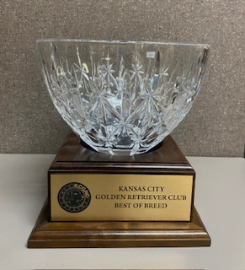
KCGRC  Best of Opposite Sex  Trophy | 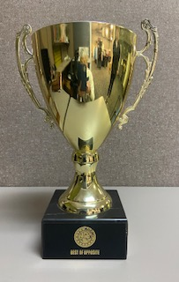

The KCGRC Best of Breed Trophy and the KCGRC Best of Opposite Sex Trophy shall be awarded to the dog/bitch who have accumulated the highest number of AKC Championship (CH) and/or Grand Championship (GCH) points during the earning period. Qualifying points for this award may be accumulated toward the dog's CH and/or GCH titles (including Bronze, Silver, Gold and Platinum), and the dog handled to these wins by the member/owner. The member/owner is defined as an individual listed on the registration certificate and responsible for 50% or more of the financial support of the dog. If the dog has accumulated the points while being handled by someone other than the member/owner, the points are awarded at ½ the point value of the win. National Owner Handler (NOH) points and Puppy of Achievement (POA) points do not count toward these awards. Members will be responsible for providing a record of the points accumulated for the dog during the earning period. If you haven't maintained a log of your own on this dog's wins you can access it for a fee via the AKC website (see below). Submit a copy of only the applicable year's wins with your award application.

The following link will provide the member with an option to purchase an AKC Points Progression report containing the number of points won by the dog in the earning period (note: the URL link to allow the member to access the report is included on the purchase receipt):

- https://shop.akc.org/products/proshop-akc-points-and-awards-report?variant=40826325598302

If the member needs to obtain GCH points for a dog who has already achieved the CH title in prior years, the following link to the AKC Grand Champions Points Ranking report may be used to obtain points for free by choosing the correct year, breed and state on the drop-down menus (NOTE: this link does NOT provide points accumulated toward the CH title):

- https://www.apps.akc.org/apps/grand_championship/index.cfm?type=gc&section=gcp
In the case of a tie, the member(s) will be advised by the trophy committee to submit the number of dogs beat in their Best Of Breed wins during this earning period.

Hummel’s Memorial  Traveling  Obedience  Trophy | 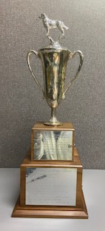

Irene and Carl Hummel were members of the club for many years and die-hard obedience competitors with their Papillons and Pomeranians – dubbed mini goldens. They did not own a golden, but their daughter Carol did. The Hummels volunteered and worked alongside members at many club events. Irene was a great cook and influencer for our KCGRC Club Cookbook published in 1983 as a fund-raiser. Irene was well known for dressing her tiny dogs for therapy visits. Both Irene and Carl were loved dearly.

This perpetual trophy is awarded to the highest scoring Golden Retriever and member owner handler who has earned any obedience title in that calendar year. The winner will be based on the 3 highest scores submitted in earning this obedience title.

KCGRC  Mitchell Ambassador Award | 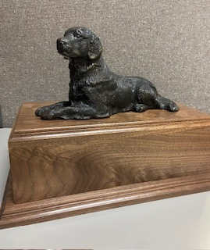

This perpetual award was established in 2024 to honor Judy & Carl Mitchell for their dedication to the club over many years. The Mitchells were preparing that year to relocate to Nebraska to be near their daughter and were sorting through a collection of a lifetime with their golden retrievers. Judy passed on this beautiful sculpture to the club for their annual raffle. Its destiny, however, was to honor them for years to come through this annual award. The base was lovingly crafted by Jerry Ewing.

This perpetual trophy is awarded to a NEW (3 years or fewer) KCGRC Member who has contributed to the club in various capacities of volunteerism, has shown a willingness to help others, has jumped in with both feet to get involved and support the breed or overall sport of dogs. Alternately, this trophy may be awarded to a golden retriever 8 years of age or older who continues to represent and promote the breed by staying active as a senior dog. Senior goldens have a way of captivating visitors with those “sugar faces” and pleasing temperaments, as they share their joyous outlook on daily life. Examples could be visiting schools, therapy, service, scent work, and well beyond etc.

Being an Ambassador of Goldens, whether by human or dog, is what the KCGRC was founded on and which this trophy celebrates. Nominations, either self-nominated or by another club member, should be submitted to the Trophy Chair no later than February 1 of each year. Along with the nomination, include a resume of no more than 200 words to indicate the reasons this individual or dog is deserving of this award.

KCGRC  Top Rally Award | 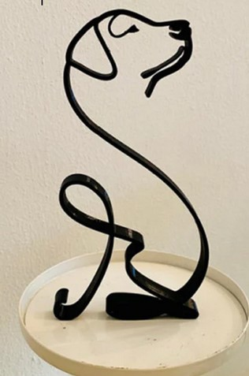

This perpetual award was established by the club in 2024 for Rally enthusiasts and their dogs to celebrate achievements in the sport. At all competitive levels the sport of Rally demonstrates teamwork. You and your dog navigate the course side by side, containing 10-20 different signs that provide instructions for the next skill to be performed.

This Trophy will be presented annually, at the Annual Awards Banquet, to the team with the average of the 3 highest scores in achieving the most advanced title of that year. In addition, there will be points added to the average. Those points are as follows:

Rally Titles Earned Point Values

Novice Titles | 10 Points
Intermediate Titles | 20 Points
Advanced Titles | 35 Points
Excellent Titles | 50 Points
Advanced Excellent Titles | 75 Points
Master Titles | 100 Points
RACH Titles | 200 Points
(Example: Title achieved RA with average score 90 plus 35 points =125 score)
KCGRC  Obedience  Versatility  Trophy | 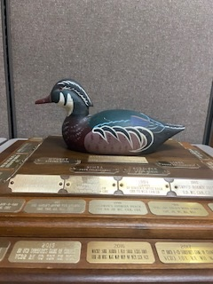

The 1982 KCGRC Obedience Team participated in the Obedience Team Competition at the National Specialty in Chicago, IL. The team members were Linda Olson and Scamper, Steve Ridge and Nugget, Sara Karl and Linus, Neida Heusinkvelt and Libbe, and Peter Zelechoski and Simba. The team won 1st Place and was awarded a Hand Painted Decoy (which was replaced due to wear in 2024). The team unanimously decided to donate the trophy and named it the KCGRC Versatility Trophy because all members had obedience titles and had earned recognition in another area as well. In 1988, the Trophy Committee, with permission, added the word obedience to the trophy’s title.
This perpetual trophy is awarded to the highest scoring Golden Retriever and handler who has earned any obedience/tracking title in that calendar year and who has also competed successfully in another area of recognized dog competition in the same calendar year with the same handler or a member of the handler’s immediate family. (NOTE: As with AKC and GRCA, Tracking falls under the category of Obedience.)
KCGRC  Obedience  TOP DOG  Award  Plaques | 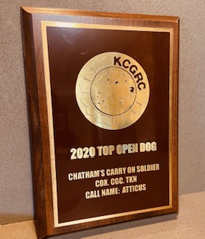

These Individual Award Plaques will be awarded to the 3 top obedience teams that competed in the regular obedience classes of Novice, Open, or Utility. Each submission will consist of the 3 qualifying scores received to obtain these titles. The average score will be used to determine the winners of each level of obedience. If a tie exists a 4th score will be used.

KCGRC Versatility Award Certificate

This Award fund was established in 1990 to encourage versatility in golden retrievers. While similar to the GRCA Versatility Award, the KCGRC Award is easier to attain. Any dog/owner team continuing to compete in multiple areas will soon become eligible for the GRCA Versatility Award Certificate. This allows a dog/owner team to be eligible for two levels of versatility.

The KCGRC Versatility Award Certificate will be awarded to any dog/owner team who successfully competes in three different areas, i.e. AKC Obedience/Tracking, Conformation, and Field. (NOTE: As with AKC and GRCA, Tracking falls under the category of Obedience.) The Versatility Award Certificate is awarded once over the lifetime of that dog and is awarded at the trophy banquet the year the dog earns their title in the third area. (Example: A CH dog who earns his/her CD in 2007 and then his/her JH in 2008 will receive a KCGRC Versatility Award Certificate at the 2009 Awards Banquet.)

"Successfully" competing is defined as follows:

Obedience /Tracking - completion of one or more of the following:
- Companion Dog CD or beyond
- Tracking Dog TD or beyond

Conformation:
- Earning a minimum of 3 points in breed competition

Field - completion of one or more of the following:
- Working Certificate WC or greater (GRCA)
- Junior Hunter JH or greater
- Judges Award of Merit JAM in a Field Trial

